PoC Assembly - Member Settings Service - Savable Search API
Deployment Guide

Revision History
Author | Revision Number | Date
TCSASSEMBLER | 1.0 | 10.12.2014

Deployment Instructions 3
1. Organization of Submission 3
2. Application Setup 3
3. Configurations 3
5. Verification 4
6. Resource Contact List 9

Deployment Instructions

Organization of Submission

tc-user-settings is root directory for nodejs app
readme.md contains configuration and deployment steps
server.js is main application entry
postman.json contains api definition for postman
docs contains documents (this file)
Other files or directories represent/contain the source code for the API

Application Setup

See readme.md

Configurations
See readme.md

- Deployment Instructions

See readme.md

Verification

Open postman
Test Create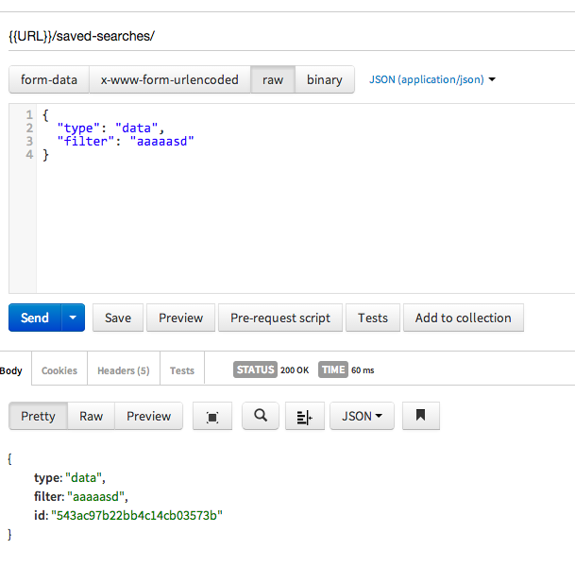

Get all

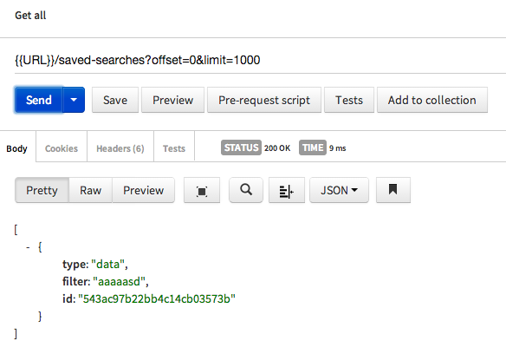
You can create more records and test offset and limit
Copy id and test Get

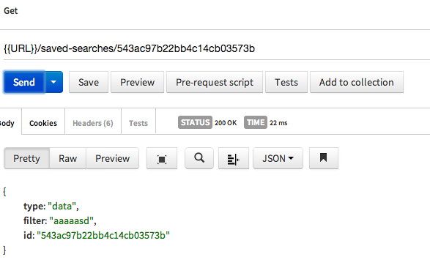

Test Update for same id

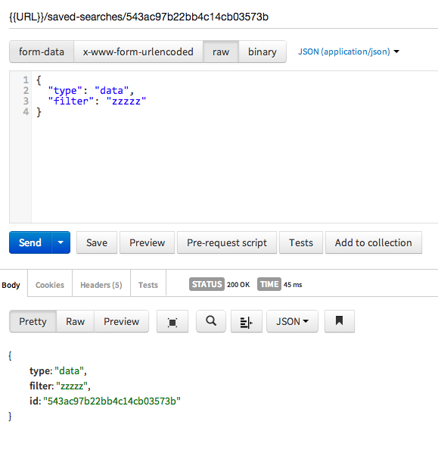

Test delete

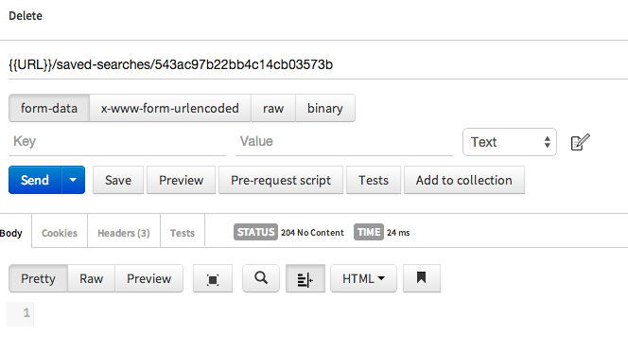

Sample error handling
Unknown type in Create

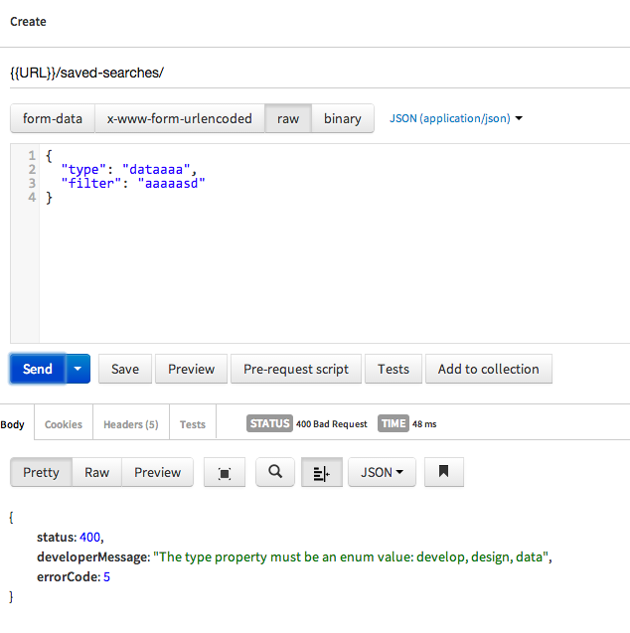
Missing property
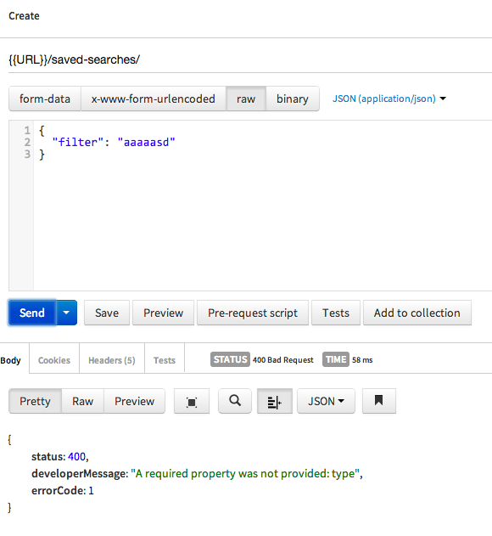

Not found entity
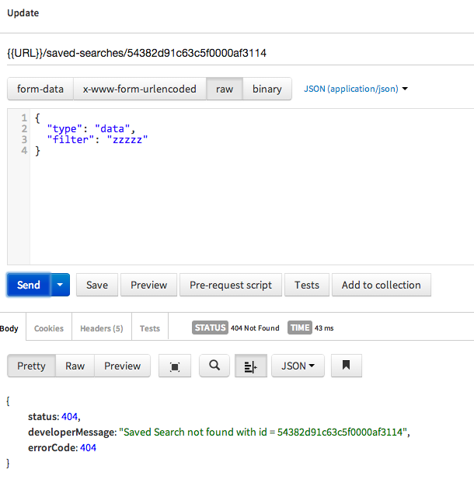

Create few records
Verify Get all if returns them all
Change MOCK_USER_ID in config.js file to different id
Restart server
Call Get all it should display empty list

Resource Contact List

Name | Resource Email
TCSASSEMBLER

